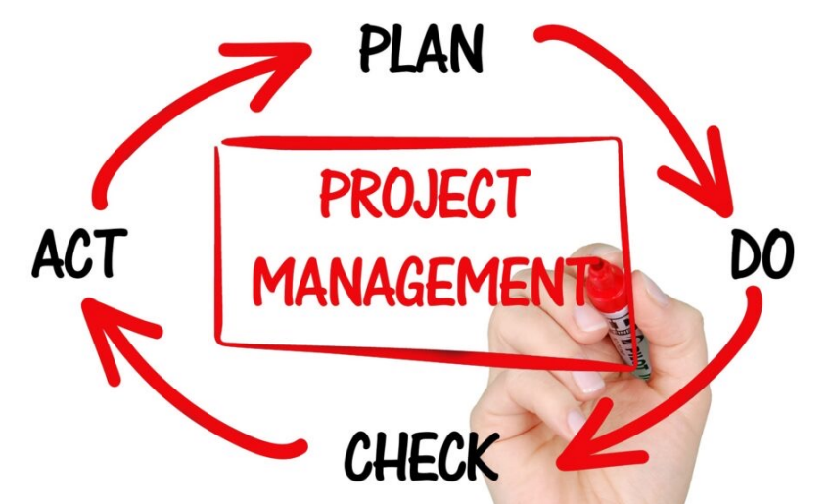**Phases of a project**

1. Initiation
2. Planning
3. Implementation
4. Closing

**Initiation phase**

1. The project sponsor is identified
2. Scope and deliverables are defined
   1. Relationship to organizational goals is key
3. Budget is approved
4. Broad statements are made about risks, approaches, timelines
5. Stakeholders are identified
6. The project Manager is assigned
7. At the end of a phase, an approved project charter is the approval to proceed to the planning phase

**Planning phase**

1. Deliverables are clearly defined
2. Based on the deliverables, a work breakdown structure or WBS defines the “work packages”
3. The work packages are used to develop a schedule
4. Plans are made for the management of stakeholders, communication, quality, costs, risks, procurement, and resources including human resources

**Implementation (Execution) Phase**

1. The project team is hired and developed
2. Procurements take place
3. Project work is underway
4. Project must be monitored and changes managed
5. Communication with stakeholders is an important ongoing activity

**Closing phase**

1. Reporting
2. Closing out procurements—final payments
3. Identify lessons learned
4. Celebrate

**Summary**

1. Project Phases
2. Initiation
3. Planning
4. Implementation (Execution)
5. Closing